Directions: Write the equation shown by each hanger, then solve for x.
1.  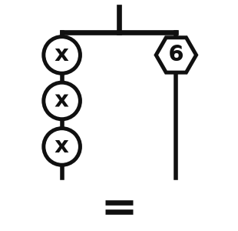 | 2.  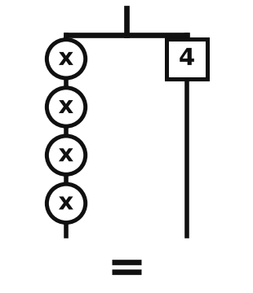 | 3.  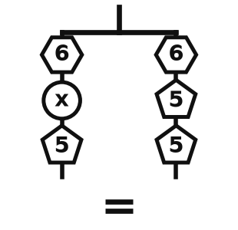
4.  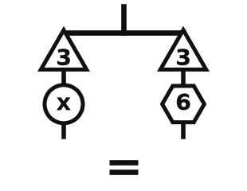 | 5.  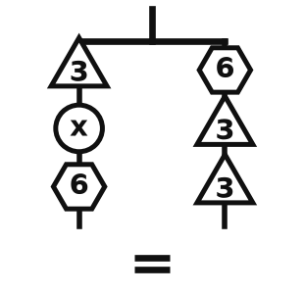 | 6.  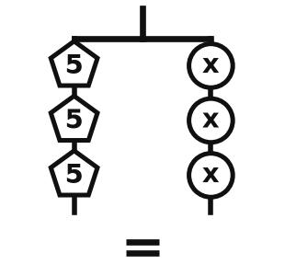
7.  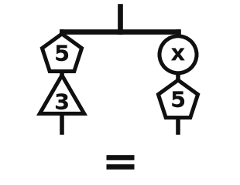 | 8.  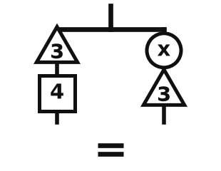 | 9.  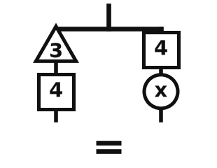

10.  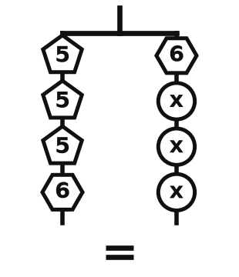 | 11.  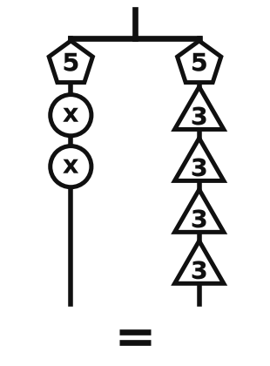 | 12.  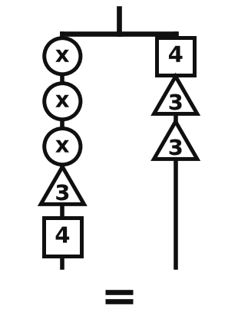
13.  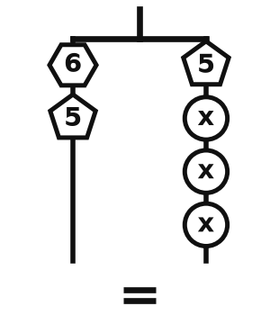 | 14.  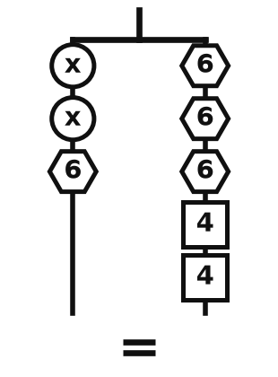 | 15.  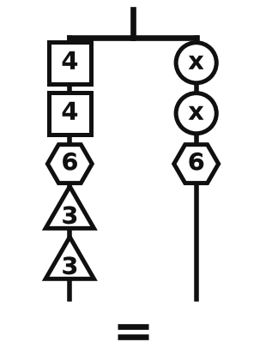
16.  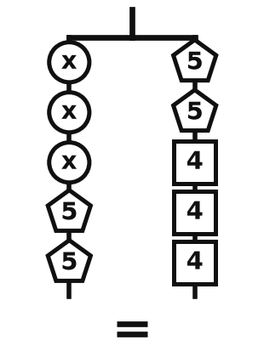 | 17.  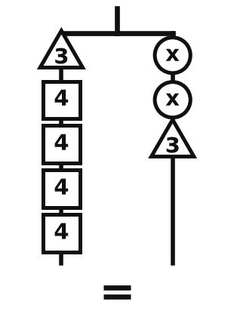 | 18.  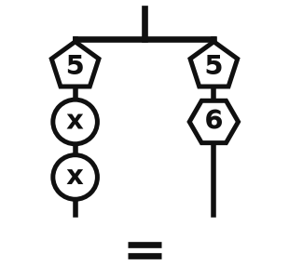

19.  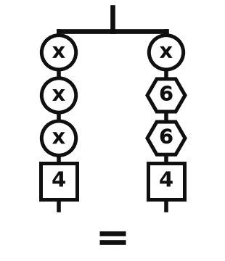 | 20.  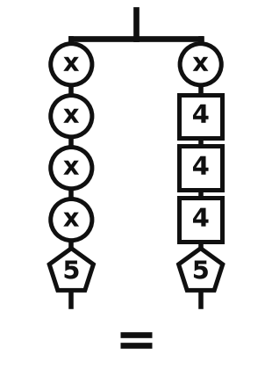 | 21.  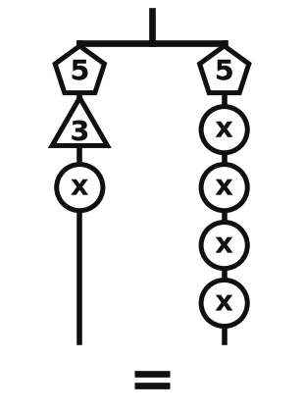
22.  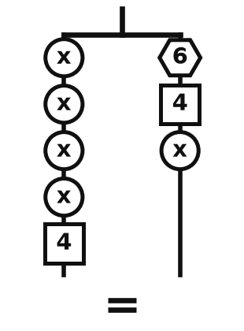 | 23.  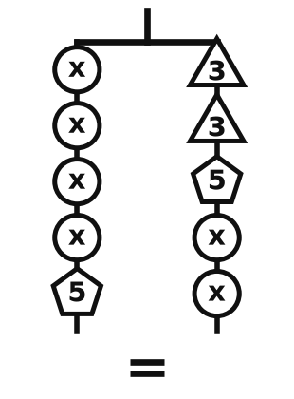 | 24.  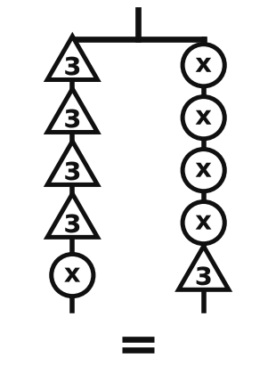
25.  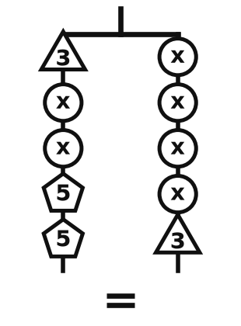 | 26.  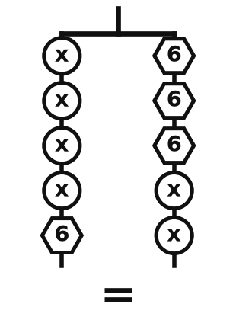 | 27.  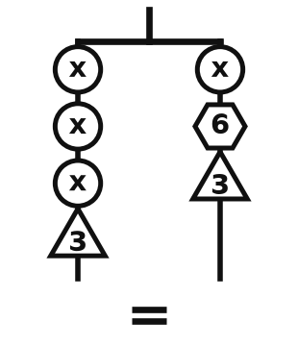

Make your own in seconds
This pack was made with IDV Worksheets. In the app you can:
• Make a whole worksheet of one problem type, or mix two, three or more
• Add problems from any other topic to the same sheet
• Pick Easy, Medium or Hard, and how many problems you want
• Get brand-new problems and a matching answer key every time you click
Try it free for 2 days, no credit card: app.idvworksheets.com

Answer Key
1. 3x = 6; x = 2 | 2. 4x = 4; x = 1 | 3. x + 11 = 16; x = 5
4. x + 3 = 9; x = 6 | 5. x + 9 = 12; x = 3 | 6. 15 = 3x; x = 5
7. 8 = x + 5; x = 3 | 8. 7 = x + 3; x = 4 | 9. 7 = x + 4; x = 3
10. 21 = 3x + 6; x = 5 | 11. 2x + 5 = 17; x = 6 | 12. 3x + 7 = 10; x = 1
13. 11 = 3x + 5; x = 2 | 14. 2x + 6 = 26; x = 10 | 15. 20 = 2x + 6; x = 7
16. 3x + 10 = 22; x = 4 | 17. 19 = 2x + 3; x = 8 | 18. 2x + 5 = 11; x = 3
19. 3x + 4 = x + 16; x = 6 | 20. 4x + 5 = x + 17; x = 4 | 21. x + 8 = 4x + 5; x = 1
22. 4x + 4 = x + 10; x = 2 | 23. 4x + 5 = 2x + 11; x = 3 | 24. x + 12 = 4x + 3; x = 3
25. 2x + 13 = 4x + 3; x = 5 | 26. 4x + 6 = 2x + 18; x = 6 | 27. 3x + 3 = x + 9; x = 3

