1. The lists show daily sales (⁠$⁠). Which group's data vary more?  Store A: 2, 5, 11, 13, 17, 19  Store B: 15, 18, 18, 18, 20, 23, 24, 25  A) Store A, because its range is 17  B) They vary the same amount  C) Store B, because its median is higher  D) Store B, because its range is 10 | 2. Two angles are supplementary. One measures 67°. What is the measure of the other?  A) 23°  B) 67°  C) 113°  D) 293° | 3. A coat costs $144, and a coupon takes 25% off. Then 15% tax is added. What is the final amount? Calculator  A) $108  B) $124.20  C) $129.60  D) $144
4. In a random sample of fish from a lake, 15% are trout. The lake has 2,600 fish. About how many trout are in the lake? Calculator  A) 15  B) 390  C) 2,210  D) 39,000 | 5. A plane cuts a sphere through its center. What is the shape of the cross section?  A) Rectangle  B) Square  C) Circle  D) Triangle | 6. A spinner has 10 equal sections, one of them red. It landed on red 7 times in 20 spins. Which probability of red is greater, and by how much?  A) Theoretical, by $\frac{1}{4}$  B) Experimental, by $\frac{1}{4}$  C) Experimental, by $\frac{1}{2}$  D) They are equal
7. A circle has a radius of 14 cm. What is its circumference? Use 3.14 for π. Calculator | 8. Which decimal is equal to this fraction?  $\frac{1}{8}$ | 9. Two lines cross. A pair of vertical angles measure  (⁠4x +⁠ 25⁠)° and (⁠2x +⁠ 41⁠)°. What is the value of x?  A) 8  B) 11  C) 19  D) 57
10. A card is picked from cards numbered 1 to 10 and put back, 100 times. How many times do you expect it is a 7?  A) 10  B) 13  C) 50  D) 90 | 11. Solve for x.  -3.5x = -28 | 12. Avery made 35 of 40 shots. If Avery takes 200 more shots, about how many will go in?  A) 25  B) 35  C) 175  D) 210
13. Alex pays $5 to get into a zoo and buys animal feed cups for $3.50 each. Alex spends $29.50 in all.  Which equation finds x, the number of feed cups?  A) 5 + 3.5x = 29.5  B) 5x + 3.5x = 29.5  C) 3.5x - 5 = 29.5  D) 3.5 + 5x = 29.5 | 14. 4.4 pounds of cheese cost $11. What is the price for each pound?  A) $0.40  B) $2.50  C) $6.60  D) $48.40 | 15. A leaky faucet drips 3 cups of water each hour. How many cups does it drip in 7 days? Calculator
16. How many real solutions does each equation have? Write each one in the correct box.  x² = 0  x² = 4  x³ = -27  x² = -10 | 17. Which relations are functions? Select all that apply.  ☐ A) {(⁠-⁠1,⁠ -⁠4⁠), (⁠4,⁠ -⁠4⁠), (⁠9,⁠ 5⁠), (⁠2,⁠ 11⁠)}  ☐ B) {(⁠-⁠2,⁠ -⁠2⁠), (⁠-⁠2,⁠ 10⁠), (⁠7,⁠ -⁠2⁠), (⁠4,⁠ 12⁠)}  ☐ C) {(⁠4,⁠ 1⁠), (⁠1,⁠ -⁠4⁠), (⁠4,⁠ 0⁠), (⁠6,⁠ 4⁠)}  ☐ D) {(⁠2,⁠ 5⁠), (⁠2,⁠ 12⁠), (⁠-⁠4,⁠ 11⁠), (⁠7,⁠ 7⁠)}  ☐ E) {(⁠1,⁠ 6⁠), (⁠0,⁠ 12⁠), (⁠-⁠2,⁠ 6⁠), (⁠-⁠1,⁠ 3⁠)} | 18. The graph shows a system of two equations. What is its solution?  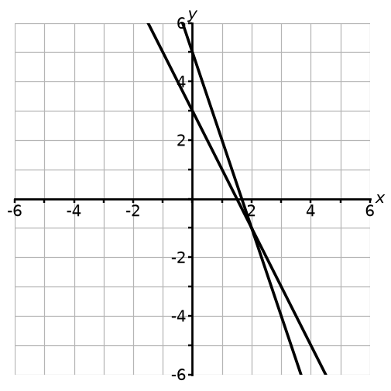  A) (⁠0,⁠ 3⁠)  B) (⁠2,⁠ -⁠1⁠)  C) (⁠-⁠1,⁠ 2⁠)  D) (⁠3,⁠ -⁠3⁠)
  Two solutions | One solution | No solution
19. The graph shows the water a pump moves over time. What is the unit rate, in gallons per minute?  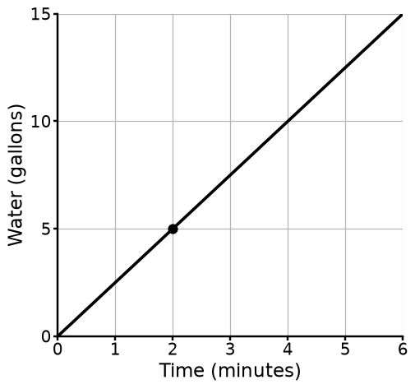  A) 0.4  B) 2  C) 2.5  D) 5 | 20. The table shows the fare y, in dollars, for a taxi ride of x miles. The pattern is linear. What is the value of y when x = 0?  A) 12  B) 23  C) 59  D) 95 | 21. The table shows the words a typist types over time. What is the unit rate, in words per minute?  A) $\frac{1}{3}$  B) 3  C) 6  D) 9
  Distance (⁠miles⁠) | Fare (⁠$⁠)
  3 | 59
  4 | 71
  5 | 83
  6 | 95
  Time (⁠minutes⁠) | Words typed
  2 | 6
  5 | 15
  8 | 24
  11 | 33
22. The dot plot shows how many pencils each student has. How many students are shown in the dot plot?  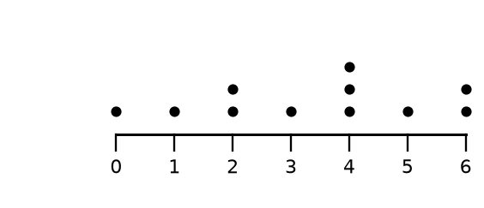 | 23. Does the graph show a proportional relationship?  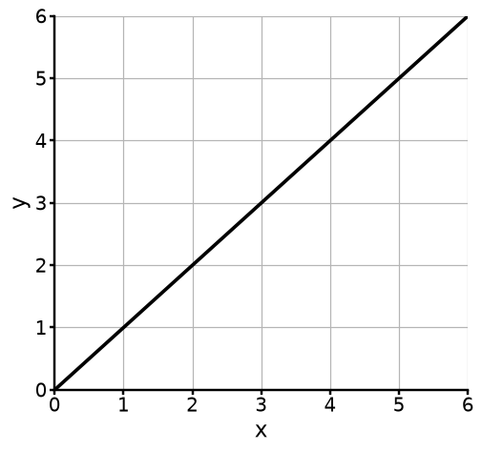  A) No. The graph is not a straight line.  B) Yes. The graph goes up from left to right.  C) Yes. It is a straight line through  (⁠0,⁠ 0⁠).  D) No. The line does not go through  (⁠0,⁠ 0⁠). | 24. A leaky faucet drips 30 cups of water in 3 hours.  Part A: Write an equation for y, the cups dripped in x hours.  Part B: How many cups is that in 23 hours?

Make your own in seconds
This pack was made with IDV Worksheets. In the app you can:
• Make a whole worksheet of one problem type, or mix two, three or more
• Add problems from any other topic to the same sheet
• Pick Easy, Medium or Hard, and how many problems you want
• Get brand-new problems and a matching answer key every time you click
Try it free for 2 days, no credit card: app.idvworksheets.com

Answer Key
1. A) Store A, because its range is 17 | 2. C) 113° | 3. B) $124.20
4. B) 390 | 5. C) Circle | 6. B) Experimental, by $\frac{1}{4}$
7. 87.92 cm | 8. 0.125 | 9. A) 8
10. A) 10 | 11. 8 | 12. C) 175
13. A) 5 + 3.5x = 29.5 | 14. B) $2.50 | 15. 504
16. Two solutions: x² = 4; One solution: x² = 0, x³ = -27; No solution: x² = -10 | 17. A) {(-1, -4), (4, -4), (9, 5), (2, 11)}, E) {(1, 6), (0, 12), (-2, 6), (-1, 3)} | 18. B) (2, -1)
19. C) 2.5 | 20. B) 23 | 21. B) 3
22. 11 | 23. C) Yes. It is a straight line through (0, 0). | 24. Part A: y = 10x; Part B: 230 cups

