1. (⁠x +⁠ 6⁠)(⁠x +⁠ 1⁠)  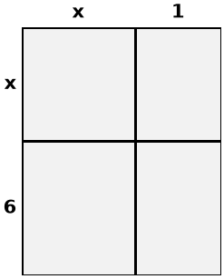 | 2. (⁠x +⁠ 9⁠)(⁠x +⁠ 5⁠)  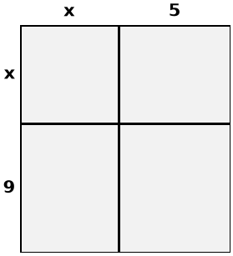 | 3. (⁠x +⁠ 3⁠)(⁠x +⁠ 3⁠)  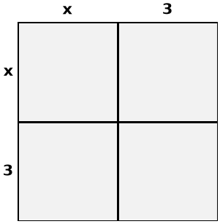
4. Factor the quadratic. Then solve.  x² - 8x = -12 | 5. Factor the quadratic. Then solve.  x² - 5x = -6 | 6. Factor the quadratic. Then solve.  x² - 12x + 27 = 0
7. Factor the quadratic. Then solve.  x² + 5x = -6 | 8. Factor the quadratic. Then solve.  x² - 2x = 63 | 9. Factor the quadratic. Then solve.  x² - x = 0
10. Solve using square roots.  (x - 8)² = 36 | 11. Solve using square roots.  (x - 2)² = 25 | 12. Solve using square roots.  (x - 3)² = 36

13. Solve by completing the square.  x² - 6x - 40 = 0 | 14. Solve by completing the square.  x² - 4x - 32 = 0 | 15. Solve by completing the square.  x² - 14x + 45 = 0
16. Solve using the quadratic formula.  x² - 6x + 6 = 0 | 17. Solve using the quadratic formula.  x² + 2x - 5 = 0 | 18. Solve using the quadratic formula.  x² - 5x - 4 = 0
19. Identify: Vertex, Axis of Symmetry, x-intercepts.  f(x) = -x² + 12x - 35 | 20. Identify: Vertex, Axis of Symmetry, x-intercepts.  f(x) = x² - 4x - 12 | 21. Identify: Vertex, Axis of Symmetry, x-intercepts.  f(x) = x² + 2x - 35

22. 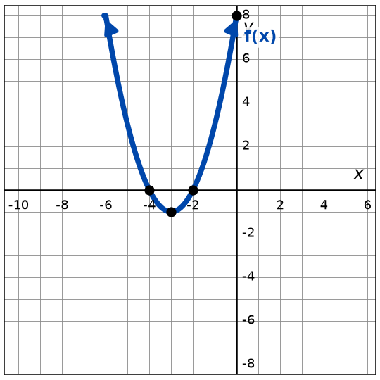  What is the vertex?  What are the zeros? | 23. 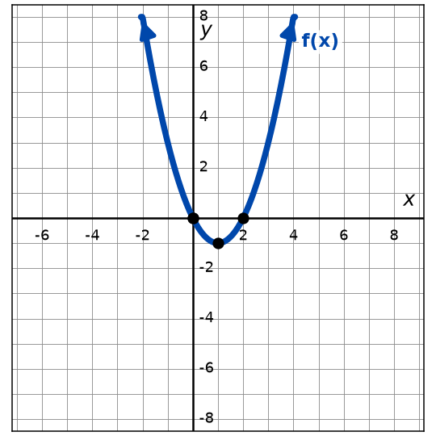  What is the vertex?  What are the zeros? | 24. 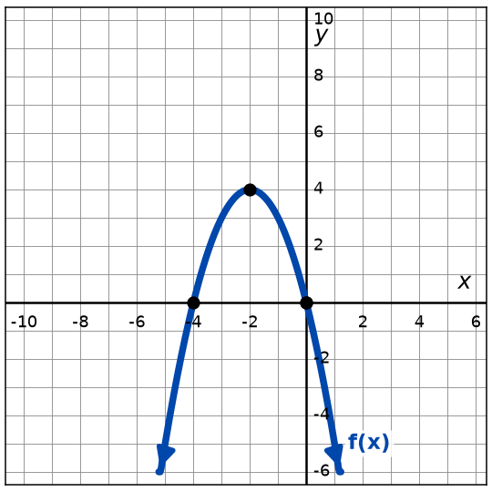  What is the vertex?  What are the zeros?
25. 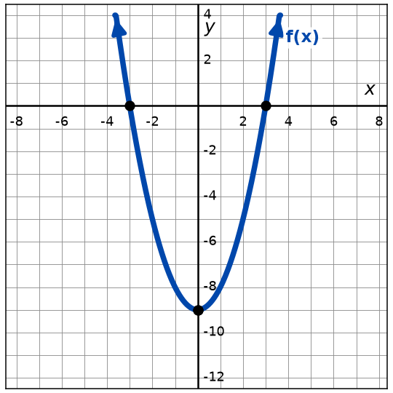  What is the vertex?  What are the zeros? | 26. 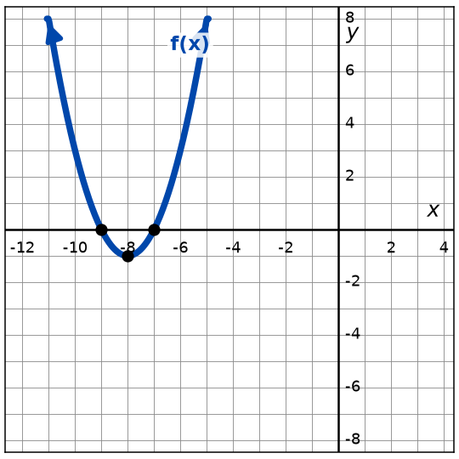  What is the vertex?  What are the zeros? | 27. 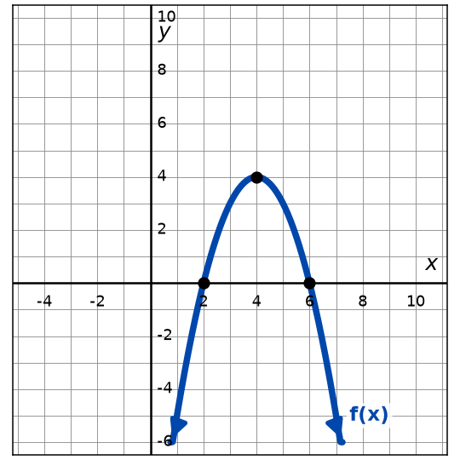  What is the vertex?  What are the zeros?
28. Casey fires a dart during a Nerf blaster battle in the backyard. The height of the dart, in feet, after t seconds is modeled by the equation below.  h(t) = -4t² + 16t + 20  Find the maximum height, the time of the maximum height, and when it hits the ground. | 29. Alex has 20 feet of fencing to build a rectangular rabbit pen. The area is A(⁠w⁠) = w  (⁠10 -⁠ w⁠), where w is the width.  What width gives the largest area, and what is that area? | 30. Riley tests a catapult built for a physics project. The height of the launched ball, in feet, after t seconds is modeled by the equation below.  h(t) = -3t² + 6t + 24  Find the starting height and when it hits the ground.

Make your own in seconds
This pack was made with IDV Worksheets. In the app you can:
• Make a whole worksheet of one problem type, or mix two, three or more
• Add problems from any other topic to the same sheet
• Pick Easy, Medium or Hard, and how many problems you want
• Get brand-new problems and a matching answer key every time you click
Try it free for 2 days, no credit card: app.idvworksheets.com

Answer Key
1. x² + 7x + 6 | 2. x² + 14x + 45 | 3. x² + 6x + 9
4. x = 2; x = 6 | 5. x = 2; x = 3 | 6. x = 3; x = 9
7. x = -3; x = -2 | 8. x = -7; x = 9 | 9. x = 0; x = 1
10. x = 14; x = 2 | 11. x = 7; x = -3 | 12. x = 9; x = -3
13. x = 10; x = -4 | 14. x = 8; x = -4 | 15. x = 9; x = 5
16. x = 3 ± √3 | 17. x = -1 ± √6 | 18. x = (5 ± √41) / 2
19. Vertex (6, 1); Zeros (5, 0), (7, 0); Axis of Symmetry x = 6 | 20. Vertex (2, -16); Zeros (-2, 0), (6, 0); Axis of Symmetry x = 2 | 21. Vertex (-1, -36); Zeros (-7, 0), (5, 0); Axis of Symmetry x = -1
22. Vertex (-3, -1); Zeros (-4, 0), (-2, 0) | 23. Vertex (1, -1); Zeros (0, 0), (2, 0) | 24. Vertex (-2, 4); Zeros (-4, 0), (0, 0)
25. Vertex (0, -9); Zeros (-3, 0), (3, 0) | 26. Vertex (-8, -1); Zeros (-9, 0), (-7, 0) | 27. Vertex (4, 4); Zeros (2, 0), (6, 0)
28. Max height 36; time 2; hits the ground at t = 5 | 29. Width 5 feet; largest area 25 square feet | 30. Starting height 24 feet; hits the ground at t = 4

