Directions: Use rigid transformations on the coordinate plane.
1. Translate the figure right 5 and up 4. Write the coordinates of the image.  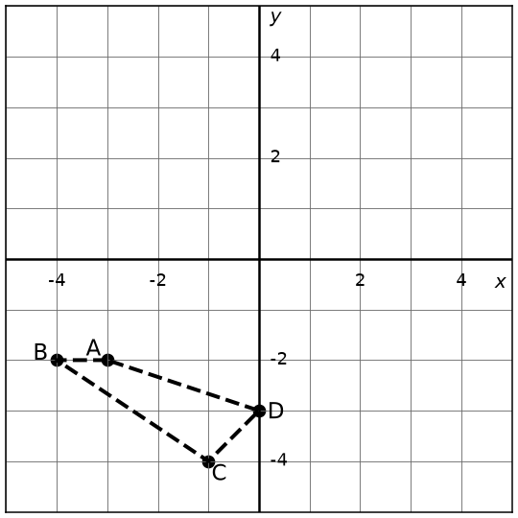 | 2. Translate the figure left 4 and up 2. Write the coordinates of the image.  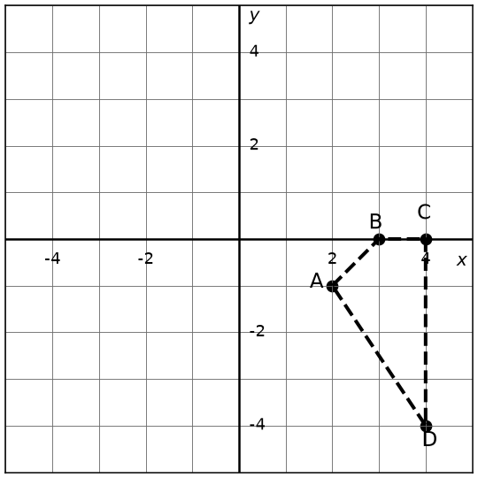 | 3. Translate the figure left 5 and up 5. Write the coordinates of the image.  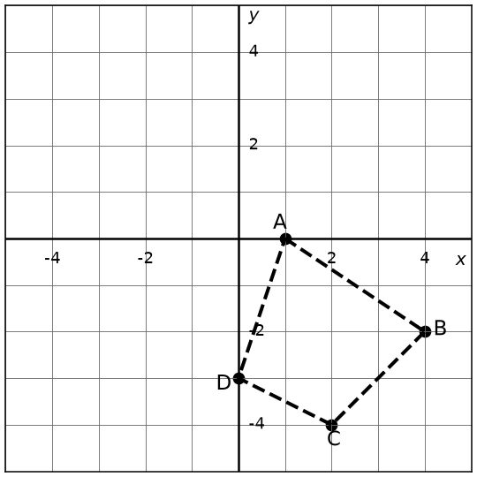
4. Reflect the figure across the y-axis. Write the coordinates of the image.  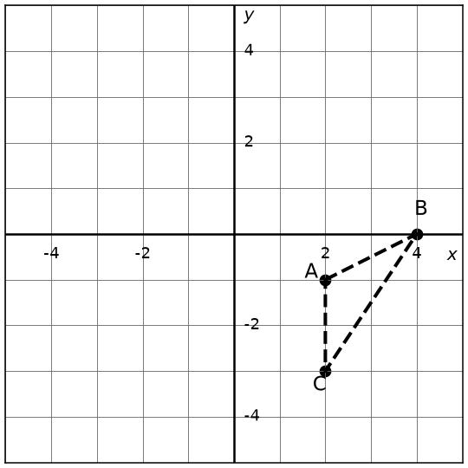 | 5. Reflect the figure across the y-axis. Write the coordinates of the image.  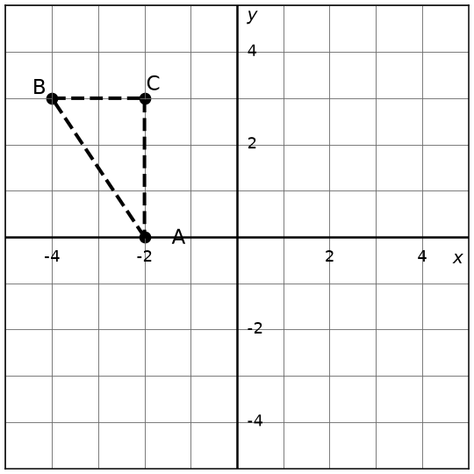 | 6. Reflect the figure across the x-axis. Write the coordinates of the image.  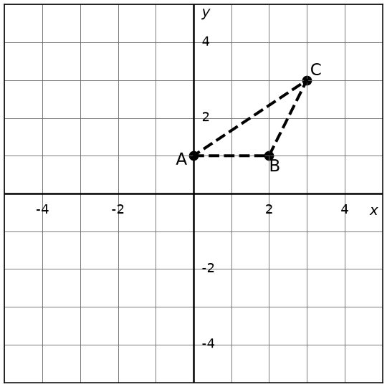
7. Reflect the figure across the y = -x. Write the coordinates of the image.  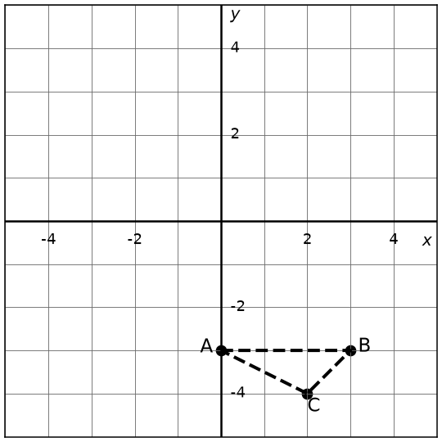 | 8. Reflect the figure across the y = x. Write the coordinates of the image.  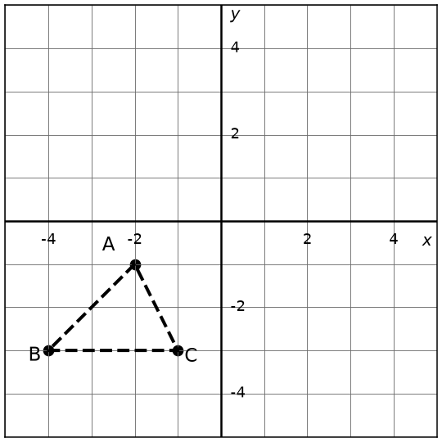 | 9. Reflect the figure across the y = -x. Write the coordinates of the image.  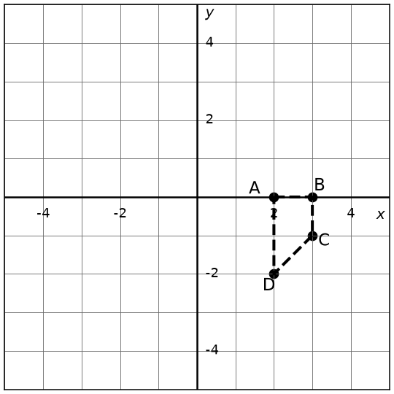
10. Rotate the figure 270° CCW about the origin. Write the coordinates of the image.  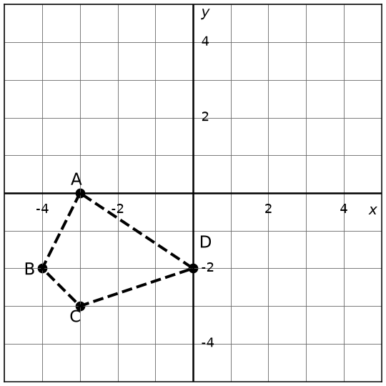 | 11. Rotate the figure 270° CCW about the origin. Write the coordinates of the image.  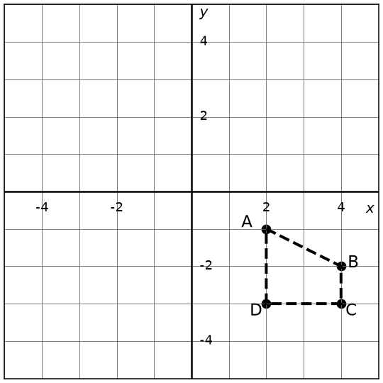 | 12. Rotate the figure 180° CW about the origin. Write the coordinates of the image.  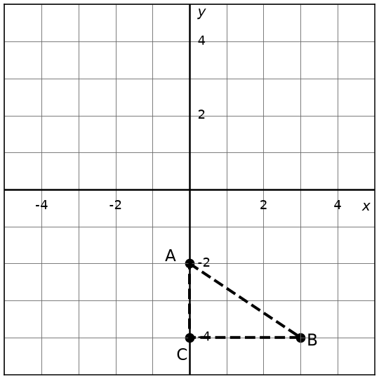

13. Identify the rigid transformation shown on the graph.  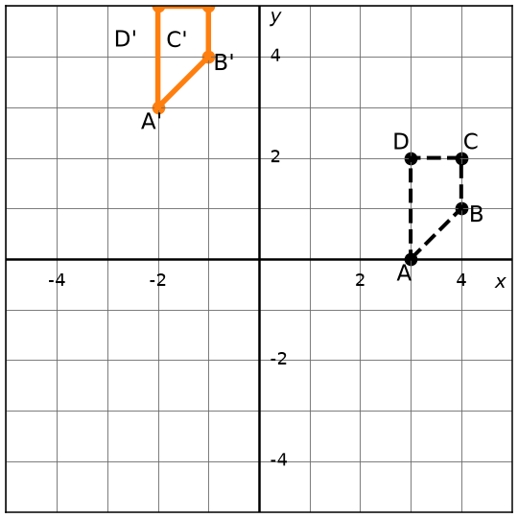 | 14. Identify the rigid transformation shown on the graph.  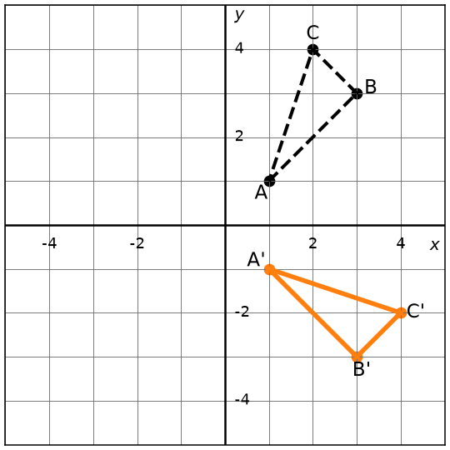 | 15. Identify the rigid transformation shown on the graph.  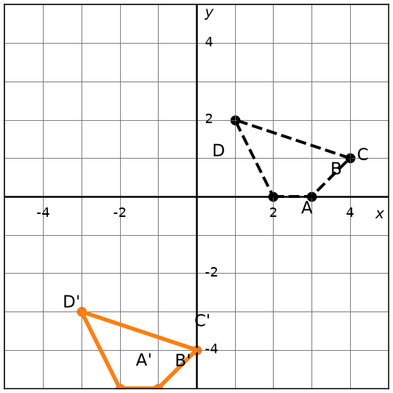
16. Identify the rigid transformation shown on the graph.  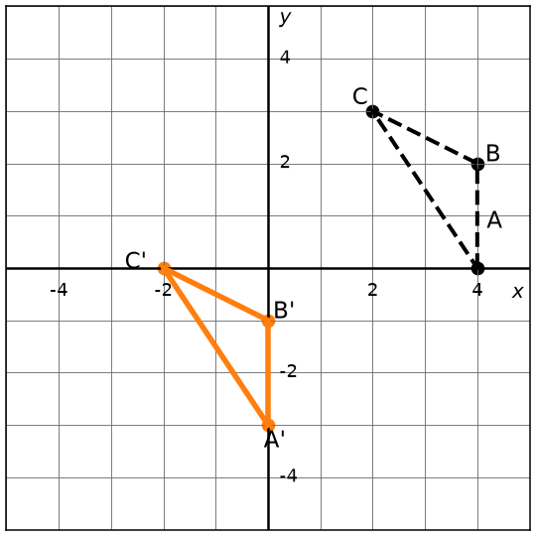 | 17. Identify the rigid transformation shown on the graph.  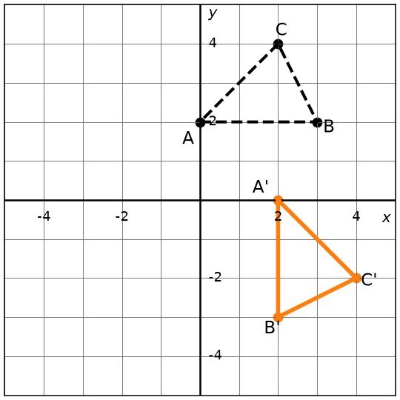 | 18. Identify the rigid transformation shown on the graph.  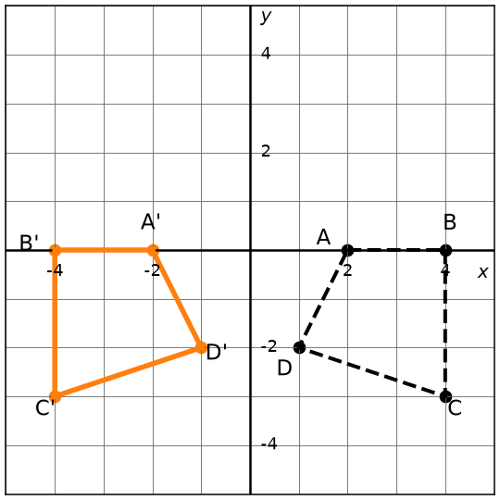
19. Quadrilateral ABCD was reflected. Which line in the image corresponds to line DA?  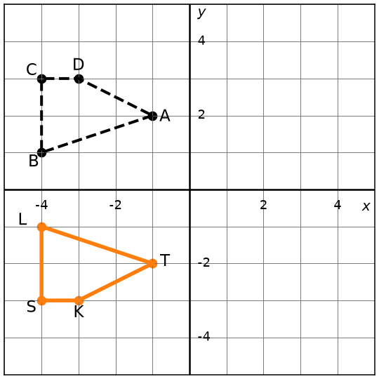 | 20. Triangle ABC was rotated. Which image angle corresponds to angle B?  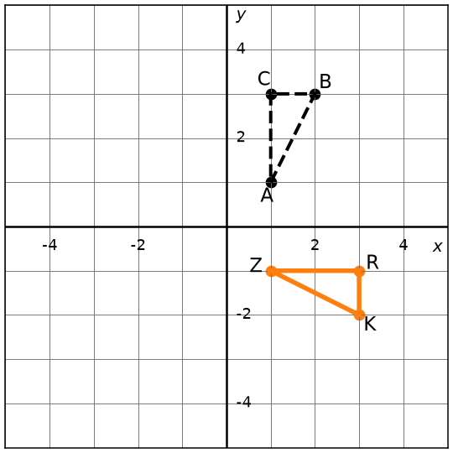 | 21. Quadrilateral ABCD was translated. What stays the same: side lengths, angle measures, or both?  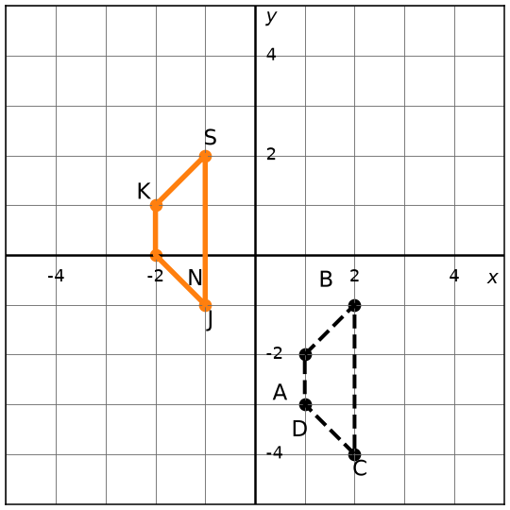
22. Quadrilateral ABCD was translated. What stays the same: side lengths, angle measures, or both?  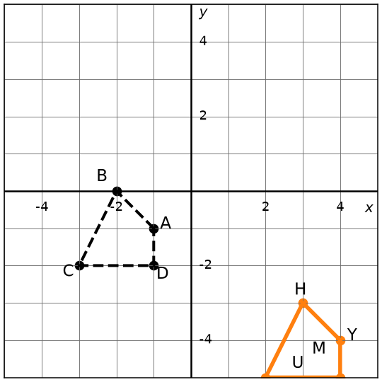 | 23. Quadrilateral ABCD was translated. Which line in the image corresponds to line AB?  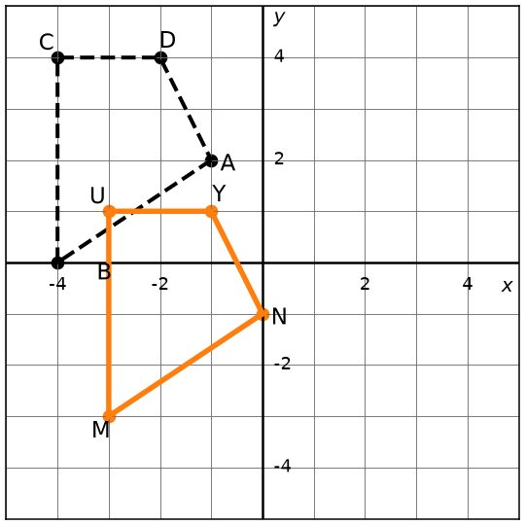 | 24. Quadrilateral ABCD was rotated. Which image point corresponds to point B?  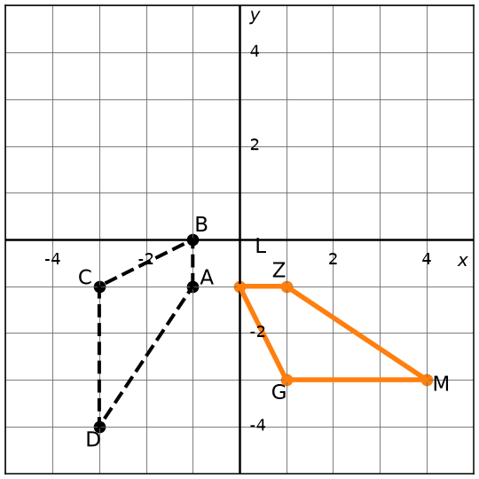

25. Point A starts at (⁠1,⁠ 4⁠).  1) reflect over the x-axis  2) rotate 180° CCW  3) translate right 3 and down 4  4) rotate 270° CW  Write the final point.  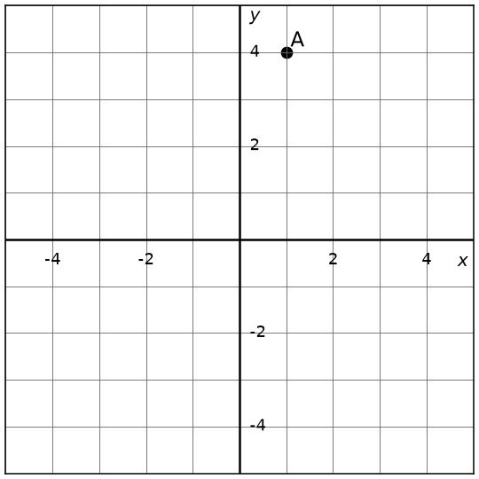 | 26. Point A starts at (⁠-⁠4,⁠ -⁠2⁠).  1) reflect over the y-axis  2) translate left 4 and up 6  3) rotate 90° CCW  4) reflect over the x-axis  Write the final point.  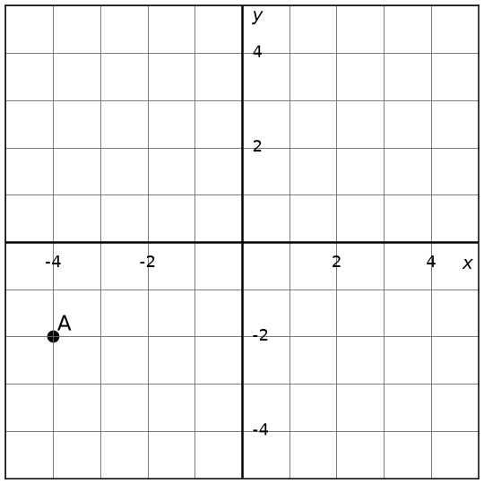 | 27. Point A starts at (⁠2,⁠ -⁠2⁠).  1) translate left 3 and up 4  2) rotate 90° CCW  3) reflect over the x-axis  4) rotate 270° CCW  Write the final point.  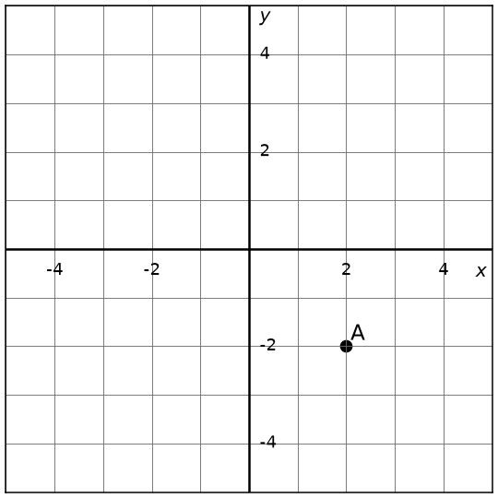
28. The figure below was transformed by two rigid motions. Identify both transformations.  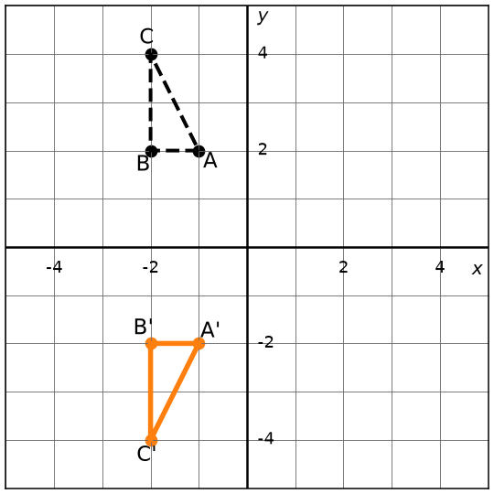 | 29. The figure below was transformed by two rigid motions. Identify both transformations.  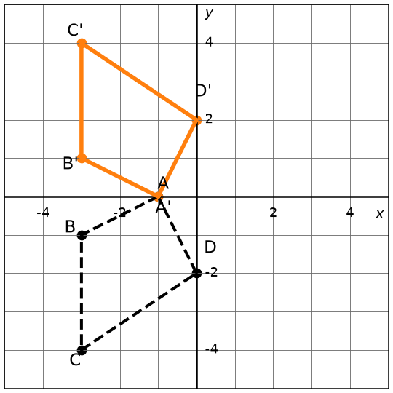 | 30. The figure below was transformed by two rigid motions. Identify both transformations.  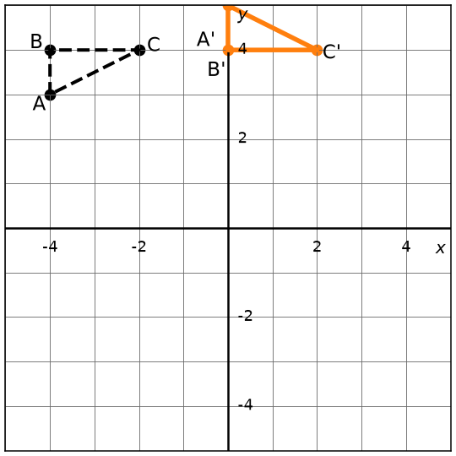
31. The figure below was transformed by two rigid motions. Identify both transformations.  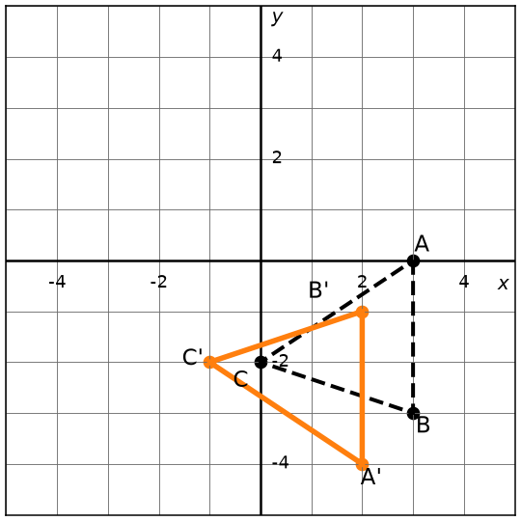 | 32. The figure below was transformed by two rigid motions. Identify both transformations.  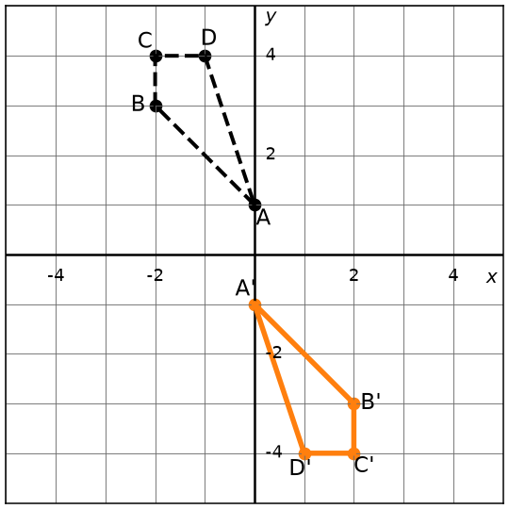 | 33. The figure below was transformed by two rigid motions. Identify both transformations.  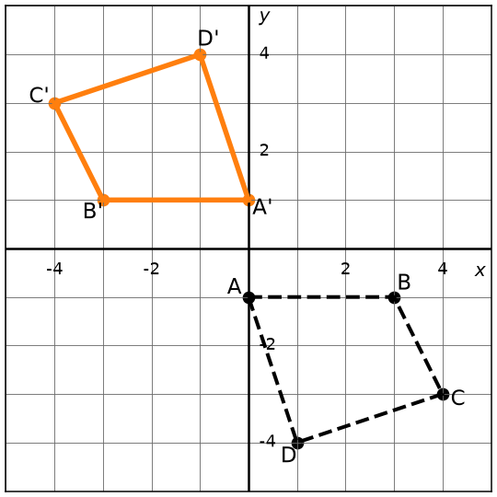

Make your own in seconds
This pack was made with IDV Worksheets. In the app you can:
• Make a whole worksheet of one problem type, or mix two, three or more
• Add problems from any other topic to the same sheet
• Pick Easy, Medium or Hard, and how many problems you want
• Get brand-new problems and a matching answer key every time you click
Try it free for 2 days, no credit card: app.idvworksheets.com

Answer Key
1. A'(2, 2), B'(1, 2), C'(4, 0), D'(5, 1) | 2. A'(-2, 1), B'(-1, 2), C'(0, 2), D'(0, -2) | 3. A'(-4, 5), B'(-1, 3), C'(-3, 1), D'(-5, 2)
4. A'(-2, -1), B'(-4, 0), C'(-2, -3) | 5. A'(2, 0), B'(4, 3), C'(2, 3) | 6. A'(0, -1), B'(2, -1), C'(3, -3)
7. A'(3, 0), B'(3, -3), C'(4, -2) | 8. A'(-1, -2), B'(-3, -4), C'(-3, -1) | 9. A'(0, -2), B'(0, -3), C'(1, -3), D'(2, -2)
10. A'(0, 3), B'(-2, 4), C'(-3, 3), D'(-2, 0) | 11. A'(-1, -2), B'(-2, -4), C'(-3, -4), D'(-3, -2) | 12. A'(0, 2), B'(-3, 4), C'(0, 4)
13. (x, y) → (x - 5, y + 3) | 14. (x, y) → (y, -x) | 15. (x, y) → (x - 4, y - 5)
16. (x, y) → (x - 4, y - 3) | 17. (x, y) → (y, -x) | 18. (x, y) → (-x, y)
19. KT | 20. ∠K | 21. Both side lengths and angle measures stay the same.
22. Both side lengths and angle measures stay the same. | 23. NM | 24. L
25. (0, 2) | 26. (-4, 0) | 27. (1, 2)
28. 1st: (x, y) → (-x, -y) 2nd: (x, y) → (-x, y) | 29. 1st: (x, y) → (-x, -y) 2nd: (x, y) → (-x, y) | 30. 1st: (x, y) → (x + 4, y - 8) 2nd: (x, y) → (x, -y)
31. 1st: (x, y) → (x - 1, y + 4) 2nd: (x, y) → (x, -y) | 32. 1st: (x, y) → (x, -y) 2nd: (x, y) → (-x, y) | 33. 1st: (x, y) → (x, -y) 2nd: (x, y) → (-x, y)

