1. The graph shows a system.  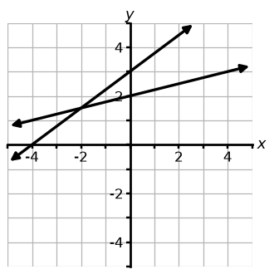  Part A: Choose its two equations.  Part B: Estimate the solution. | 2. The graph shows a system.  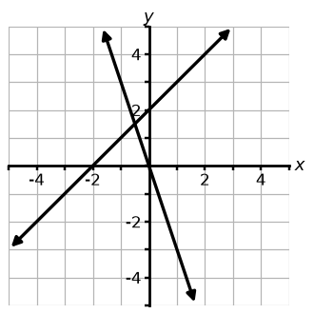  Part A: Choose its two equations.  Part B: Estimate the solution. | 3. The graph shows a system.  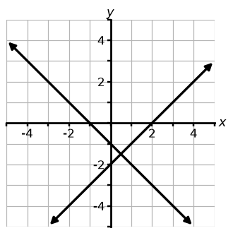  Part A: Choose its two equations.  Part B: Estimate the solution.
  ☐ A) y = $\frac{1}{4}$x + 3 | ☐ B) y = $\frac{1}{4}$x + 2
  ☐ C) y = $\frac{3}{4}$x + 3 | ☐ D) y = −$\frac{3}{4}$x + 3
  ☐ A) y = x + 2 | ☐ B) y = −2x
  ☐ C) y = −3x | ☐ D) y = −x + 2
  ☐ A) y = x − 1 | ☐ B) y = −x − 1
  ☐ C) y = x − 2 | ☐ D) y = −2x − 1
4. Use the graph. True or false?  a) A solution to -x + 1 = -2x is -1.  b) A solution to 2 = -x + 1 is -1.  c) A solution to -1 = -2x is 2.  d) A solution to -x + 1 = -2x is 2. | 5. Use the graph. True or false?  a) A solution to -2 = 2x + 4 is -3.  b) A solution to 2x + 4 = −$\frac{1}{3}$x - 3 is -2.  c) A solution to -2 = −$\frac{1}{3}$x - 3 is -3.  d) A solution to -3 = −$\frac{1}{3}$x - 3 is -2. | 6. Use the graph. True or false?  a) A solution to 4 = $\frac{1}{4}$x + 1 is 2.  b) A solution to 2 = $\frac{3}{4}$x - 1 is 4.  c) A solution to $\frac{3}{4}$x - 1 = $\frac{1}{4}$x + 1 is 4.  d) A solution to $\frac{3}{4}$x - 1 = $\frac{1}{4}$x + 1 is 2.
  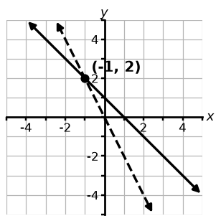 | Solid:  y = −x + 1  Dashed:  y = −2x
  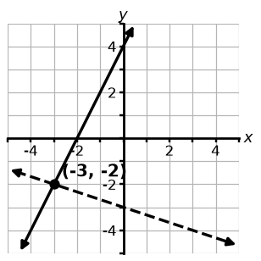 | Solid:  y = 2x + 4  Dashed:  y = −$\frac{1}{3}$x − 3
  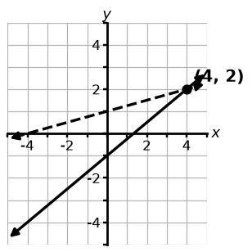 | Solid:  y = $\frac{3}{4}$x − 1  Dashed:  y = $\frac{1}{4}$x + 1
7. Which graph shows this system?  y = 3x - 1 and y = −$\frac{1}{4}$x - 1  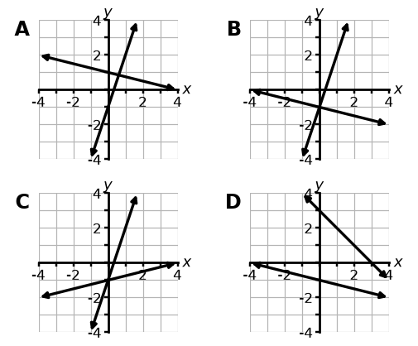 | 8. Which graph shows this system?  y = −$\frac{2}{3}$x + 2 and y = -x + 3  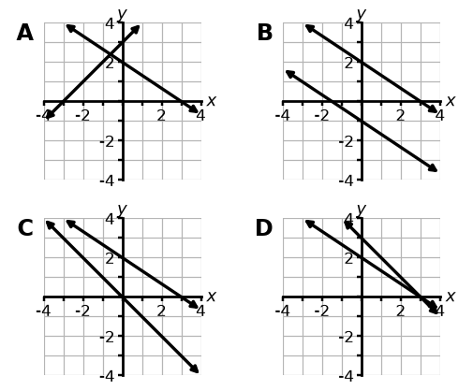 | 9. Which graph shows this system?  y = -2x and y = x - 3  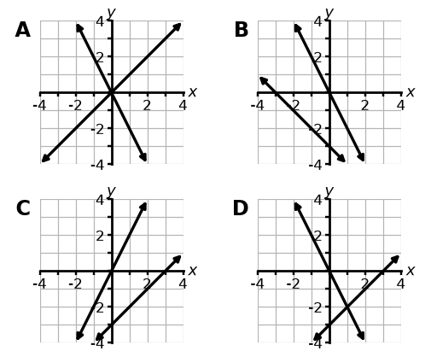

10. Graph the system and find the solution.  y = x + 4  y = −$\frac{1}{2}$x - 2  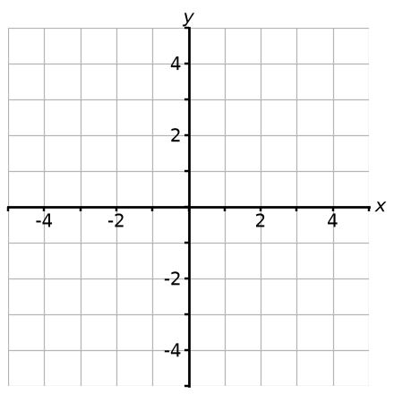 | 11. Graph the system and find the solution.  y = -x - 3  y = $\frac{1}{2}$x | 12. Graph the system and find the solution.  y = -3x - 4  y = $\frac{1}{3}$x - 4
13. Graph the system and find the solution.  y = $\frac{5}{3}$x - 4  y = -4 | 14. Graph the system and find the solution.  y = -3  y = x - 1 | 15. Graph the system and find the solution.  y = −$\frac{1}{3}$x + 3  y = $\frac{2}{3}$x + 3
16. The solution to the system is  (⁠4,⁠ 1⁠). One equation is graphed. Select all the equations that could be the other equation in the system.  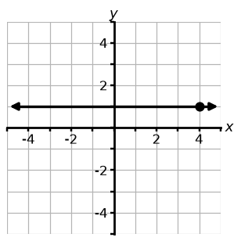  ☐ A) y = 2x - 6  ☐ B) y = -x + 5  ☐ C) y = 2x - 7  ☐ D) y = −$\frac{7}{4}$x + 8 | 17. The solution to the system is  (⁠0,⁠ -⁠2⁠). One equation is graphed. Select all the equations that could be the other equation in the system.  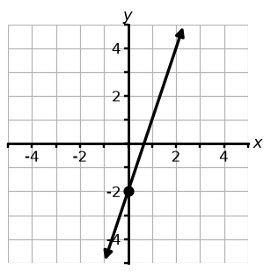  ☐ A) y = 3x - 1  ☐ B) y = $\frac{1}{3}$x - 2  ☐ C) y = −$\frac{1}{3}$x - 2  ☐ D) y = −$\frac{1}{4}$x - 2 | 18. The solution to the system is  (⁠2,⁠ -⁠4⁠). One equation is graphed. Select all the equations that could be the other equation in the system.  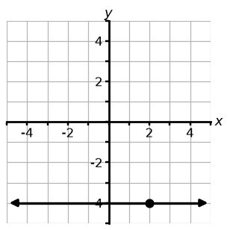  ☐ A) y = -x - 1  ☐ B) y = -x - 2  ☐ C) y = x - 2  ☐ D) y = -3x + 2

19. Here is the graph of one equation in a system. Write a second equation so the system has no solution.  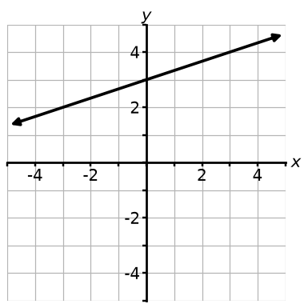 | 20. Here is the graph of one equation in a system. Write a second equation so the system has infinitely many solutions.  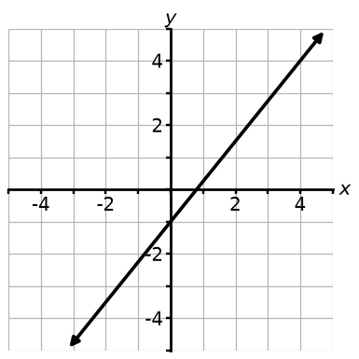 | 21. Here is the graph of one equation in a system. Write a second equation so the system has exactly one solution.  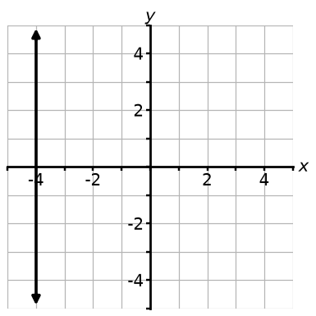
22. Alley Cat (⁠A⁠) and Pin Palace (⁠P⁠) charge for shoes plus each game.  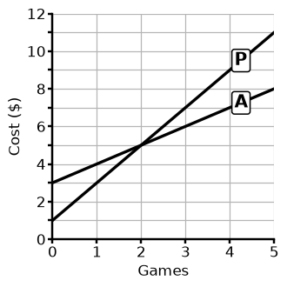  Part A: Write both equations.  Part B: What does the crossing mean? | 23. U-Move (⁠U⁠) and Truck Town (⁠T⁠) rent trucks for a fee plus each day.  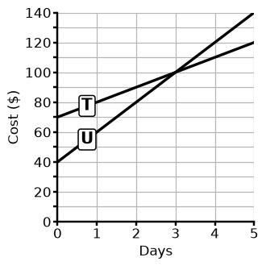  Part A: Write both equations.  Part B: What does the crossing mean? | 24. Dr. Patel (⁠P⁠) and Ms. Lee (⁠L⁠) tutor for a fee plus an hourly rate.  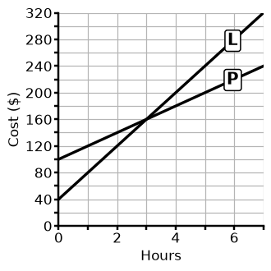  Part A: Write both equations.  Part B: What does the crossing mean?
25. Graph the system and find the solution.  7x - 4y = 0  y = −$\frac{3}{2}$x | 26. Graph the system and find the solution.  y = −$\frac{7}{4}$x - 4  y = -4 | 27. Graph the system and find the solution.  x + 4y = -4  x + 3y = -3

Make your own in seconds
This pack was made with IDV Worksheets. In the app you can:
• Make a whole worksheet of one problem type, or mix two, three or more
• Add problems from any other topic to the same sheet
• Pick Easy, Medium or Hard, and how many problems you want
• Get brand-new problems and a matching answer key every time you click
Try it free for 2 days, no credit card: app.idvworksheets.com

Answer Key
1. B, C; about (-2.0, 1.5) | 2. A, C; about (-0.5, 1.5) | 3. B, C; about (0.5, -1.5)
4. a) T, b) T, c) F, d) F | 5. a) T, b) F, c) T, d) F | 6. a) F, b) T, c) T, d) F
7. Graph B | 8. Graph D | 9. Graph D
10. (-4, 0) | 11. (-2, -1) | 12. (0, -4)
13. (0, -4) | 14. (-2, -3) | 15. (0, 3)
16. B, C, D | 17. B, C, D | 18. B, D
19. Any line with the same slope and a different y-intercept, e.g. y = $\frac{1}{3}$x | 20. The same line: y = $\frac{5}{4}$x - 1 (or any equivalent, e.g. 5x - 4y = 4) | 21. Any line that is not vertical, e.g. y = 2x - 1
22. A: y = x + 3; P: y = 2x + 1. Crossing (2, 5): bowling 2 games costs $5 at either place. | 23. U: y = 20x + 40; T: y = 10x + 70. Crossing (3, 100): renting for 3 days costs $100 at either company. | 24. P: y = 20x + 100; L: y = 40x + 40. Crossing (3, 160): 3 hours of tutoring costs $160 with either tutor.
25. (0, 0) | 26. (0, -4) | 27. (0, -1)

